**EE198A Senior Project Pre-Proposal**

Spring 2021

**Project Title:** Energy Management System for Storage Cells in Electric Vehicles

**Project Description:**

*Motivation and purpose:*

Electric Vehicle (EV) sales have been growing at a rapid pace for the past decade. The increase in electric vehicle drivers benefits the environment as it reduces carbon dioxide emissions. The Energy Management System (EMS) for Storage Cells in EVs project is meant to combine two common systems in EVs, the inverter and Battery Management System (BMS), in a more cost effective, efficient, and modular way to make EVs more appealing to customers.

*Engineering Approach:*

Our modular approach to combining the inverter and BMS includes creating a multi layer device where each layer can control its own portion of the output voltage signal. This is done to power the 3 phase DC motor, represented by the symbol “M.” In Figure 1, each phase represents a layer where each layer contains 18 submodules where each submodule is a H-bridge switch that’s capable of outputting 0V, +Vout, and -Vout.

The PCBs that contain the multilevel inverters are currently directly controlled by a Digital Signal Processing (DSP) controller and inverter that has been programmed in C using Code Composer Studio (CCS) by Texas Instruments. The code is stored and revised in an online repository on GitLab. We will be researching and revising the DSP code to integrate and control FPGA arms to control the multilevel inverters.

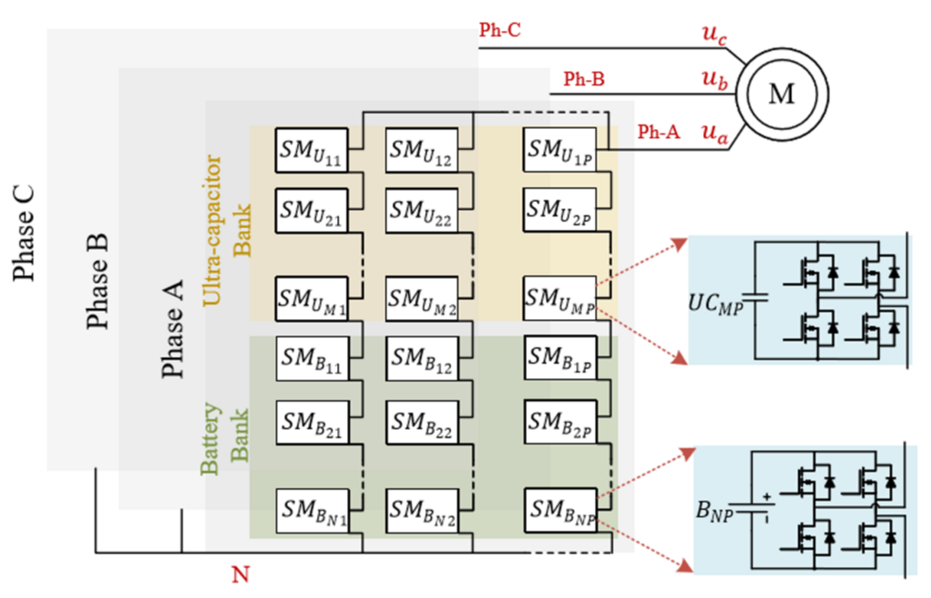

Figure 1: overall system block diagram

*End of the semester milestone:*

By the end of the semester, the hardware team will have a revised PCB design for the Modular Multilevel Converter that will be submitted for fabrication. The Embedded System team will have tested and revised previously written code on the DSP controller for FPGA integration.

**Group members and areas of responsibility**

1. Student Name: Andrew Tran
   1. Email: [andrew.c.tran@sjsu.edu](mailto:andrew.c.tran@sjsu.edu)
   2. Responsibility: Power Module Hardware and PCB Design
2. Student Name: Hiromi Saito
   1. Email: [hiromi.saito@sjsu.edu](mailto:hiromi.saito@sjsu.edu)
   2. Responsibility: Power Module Hardware and PCB Design
3. Student Name: Jonathan Austin
   1. Email: [jonathan.austin@sjsu.edu](mailto:jonathan.austin@sjsu.edu)
   2. Responsibility: Embedded Systems

Advisor (ONLY EE full-time faculty): Mohamed Badawy

Signature: ______________________________________

Date: ____________

**To advisor:** No single student project is allowed. Typical group size is 3 students (minimum is 2 students and maximum is 4 students). Before approving a group with more than 3 students, make sure that the scope of the project is broad enough so that each student has a clear area of responsibility.